**Data Flow Diagram & User Stories**

|  |  |
| --- | --- |
| Date | 24 June 2025 |
| Team ID | LTVIP2025TMID29797 |
| Project Name | workforce administration solution (dev) |
| Maximum Marks | 4 Marks |

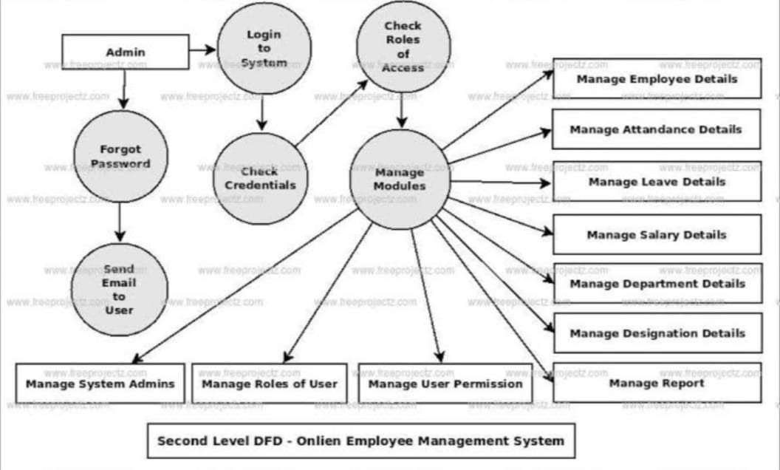Data Flow Diagrams:

A Data Flow Diagram (DFD) for a workforce administration solution would visually represent how data moves through the system, showing processes, data stores, and external entities. A basic Level 0 DFD might depict the core interactions between employees, managers, HR, and the system itself, while higher levels would delve into specific functionalities like onboarding, payroll, or performance management.

Example: [ 0 level DFD – Online Employee Management System ]

Explanation:

* Inputs:
  + Employee data from HR Department o Requests from Employees (leave applications, personal info updates)
* Process:
  + Employee Management System handles data storage, validation, approvals, updates.
* Outputs:
  + Reports and dashboards for HR and management
  + Updated employee records

User Stories

Use the below template to list all the user stories for the product.

Functional

User Story

User Type Requirement User Story / Task Acceptance Criteria Priority Release

Number

(Epic)

|  |  |  |  |  |
| --- | --- | --- | --- | --- |
| Employee | Leave  Management | USN-1 | As an employee, I want to submit leave Leave request form accessible; request requests through the portal so I can submitted successfully; confirmation High manage my time off easily. notification received. | Sprint-1 |
| Employee | Leave Management | USN-2 | As an employee, I want to view my leave  Leave balance and history displayed  balance and history so I can plan my High  accurately on dashboard.  leaves accordingly. | Sprint-1 |

|  |  |  |  |  |  |  |
| --- | --- | --- | --- | --- | --- | --- |
| User Type | Functional  Requirement  (Epic) | | User Story  User Story / Task Acceptance Criteria | | | Priority Release |
| Number | | As a manager, I want to review and Manager can view pending requests; |
| Manager | Leave Approval | | USN-3 |  | approve/reject leave requests to manage approval/rejection updates status; | High Sprint-1 |
| HR  Administrator      HR | Employee  Records  Management  Compliance |  | USN-4 |  | my team’s availability. notifications sent to employee.    As an HR admin, I want to add and Employee profiles can be update employee profiles to maintain created/edited; changes saved and accurate workforce data. reflected immediately.  As an HR admin, I want to receive alerts Automated alerts sent before expiry; | High Sprint-1 |
| Administrator | Management  Workforce |  | USN-5 |  | for expiring certifications and documents dashboard shows compliance status; to ensure compliance. audit logs maintained.    As an HR analyst, I want to generate Reports accessible; data updated in | Medium Sprint-2 |
| HR Analyst        System  (Automation) | Analytics  Workflow  Automation |  | USN-6  USN-7 |  | workforce reports (headcount, attrition, real-time; export options available.  leave trends) for informed decisions.    As a system, I want to automate leave Leave workflows automated; approvals and notifications to reduce notifications sent promptly; exceptions manual workload and errors. flagged for manual review. | Medium Sprint-2  High Sprint-1 |
| Employee | Self-Service Portal USN-8 | | |  | As an employee, I want to update my Personal info editable; changes personal information through the portal validated and saved; confirmation to keep my records current. shown. | Medium Sprint-2 |